October 6 critique of five DFBA functions: dfba_beta_contrast, dfba_beta_bayes_factors, dfba_sim_data, dfba_bayes_vs_t_power, dfba_power_curve. The critique of the other functions currently in the github store will follow in a separate document.

Section I Critique of dfba_beta_contrast:

The only problem I found was an error that I made in the documentation in the Details section after the phrase “N delta random posterior values where …”. What should follow that phrase is:

delta[j]=contrast_vec[1]*phi_1[j]+…+contrast_vec[K]*phi_K[j] for j=1,…N.

Section II Critique of dfba_beta_bayes_factor

There are several errors in the source code for this function.

1. The code has a test to see if a0 and b0 are greater than 1 as well as below 0. Both a0 and b0 can be greater than 1; in fact for an informed prior they often are the posterior a and b parameters from a previous study. Yet a0 and b0 cannot be less than zero.
2. The code has no test to see if there is an NA value for either the inputs for a,b,a0, or b0. My code did check for that.
3. In the section for method=”point” the BF10 and BF01 are reversed. The simplest fix is to have the first assignment be labelled BF01 rather than BF10 and to label the second assignment as BF10 rather than BF01.
4. I cannot tell where the code is wrong because it pertains to the output printing. In the section of the output for the prior shape parameters the labels are a and b, but they should be a0 and b0. Also the computer prints after the a0 and b0 value an extra line that repeats 1 1 n – I think comes for the cat() command “\n” might be \n instead. Finally, before the shape parameters are list for the posterior beta there ought to be a label above the parameter for a and b.

There are two minor issues in the documentation for this function. In the Value section, the definition for a is incorrect. It should be: The input value for the posterior beta first shape parameter. The other issue is in the last example. This example is important because it show how an interval Bayes factor can be used around a trivially small ban about a point. So can you add 2 comment lines above the last example which are

# An example where the null hypothesis is an interval that is

# plus or minus .0025 about the point of .5

Section III Critique of dfba_sim_data:

The current version of this function on github still has all the same problems that I talked about earlier. So, I will repeat the critique of the coding function here. The following are coding problems.

1. In two places the code is incorrect in computing the frequentist p-value. In the section for design=”independent” the pvalue should be: pvalue=1-pt(t_sample,2*n-2). This computes a pvalue greater than .5 when t_sample is negative and it should be greater than .5. We are doing a one-tail or direction t test where H0 is delta≤0 and H1 is delta>0. By using abs(t_sample), lower.tail=FALSE gets the right value only when t_sample is positive, but in subsequent Monte Carlo sampling to ascertain power, there will be cases for small delta values that t_sample is negative.
2. The same error as in (a) also occurs when design=”paired” where the pvalue should be: pvalue=1-pt(t_sample,n-1).
3. The current code can be called repeatedly by the dfba_bayes_vs_t_power function rapidly because we only have two output values—i.e., the pvalue and the prH1 value. Yet a single application of the dfba_sim_data does create two vectors E and C of scores. I think we may want to create a new function dfba_sim_data_display which is identical to the dfba_sim_data function except it outputs also the E and C data and provides a boxplot for these data. Alternatively, we might be able to change the output list in dfba_sim_data to include the E and C vectors. My worry or question is: can this be done without messing up the dfba_bayes_vs_t_power function because the E and C vectors are being passed along thousands of times? The problem with a function that outputs mainly two vectors E and C is it can be displayed in many ways, so why not just provide the user with the output vectors E and C so that they can plot it any way they please. One way to do this is the give the user a function that produces the two vectors and provides a boxplot, but they can alternatively just use the output vectors to do a different display that better meets their needs.

There is major problem with the documentation**. SEE THE ATTACHED UNFORMATED FILE FOR THE DOCUMENTATION**. This attached material should be used wholesale rather than the current documentation. Except if we change the code to deal with my point (c) above.

Section IV Critique of dfba_bayes_vs_t_power:

As far as I can tell this function has a platform sensitivity issue. I have been checking software on RStudio, a Rgui for PCs, and R console on my MAC laptop. In RStudio and for the RGui it works fine for now. I will keep working with it to see if there are problems, but it appears to be fine for RStudio and the Rgui. The problem is R console. It runs about 10 slower in R console, and it does not exit the font for the command mode. In R console on my Mac the commands are in blue font, but when the data are displayed it is in black font. Upon execution of the function in RStudio the font displays properly in black and the system is ready for the next command in blue font. With console, the display is in blue font and there is a stray message after the data frame is displayed. The message reads “for the proportion of samples detecting effects”. This message is in blue font. This problem with console does not occur with the other functions in the dfba package. So, why is it occurring in R console? I suspect it has to do that this function calls other dfba functions. RStudio and the Rgui are not having a problem with this but perhaps R console is working to hard of these reference to other functions which are not part of base R. Is there anything we can do about this problem?

I’m not experiencing the same difference in processing time – seems about the same to me between the R console and RStudio. You might consider checking the version on your R console and checking if a newer version is available.

Regarding the output bug, the same thing happens to me on my Mac when I run the function:

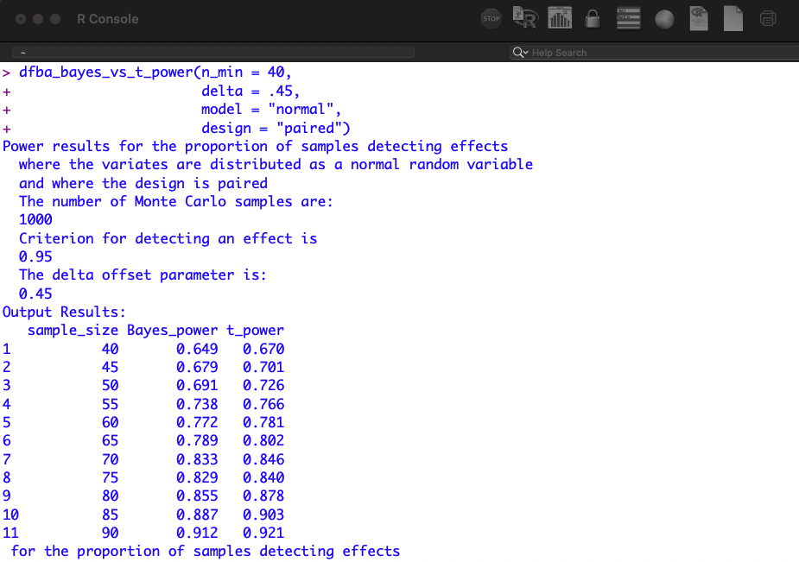

BUT, it doesn’t happen when I save the output to an object and then call the object:

I also tried it in the R console on my work PC, and there were no problems at all there.

I will keep investigating the issue, but we know that 1. It’s not a problem with the show method (because the issue doesn’t happen when an object gets printed), 2. It’s a bug that only happens running the R console on the mac (and only under certain circumstances). I don’t think it can have anything to do with cross-referenced functions because the phrase only appears in the methods and not in the functions themselves. I’m having trouble finding any help online for the problem, but it’s not an emergency, so if we haven’t figured it out by the time we submit, I think at that point we can consult the professionals directly.

The other issue with this function is the documentation is not the stuff that I developed. Consequently, I sent the unformatted text file for the documentation, which should be replace the existing documentation. **SEE ATTACHED UNFORMATED TEXT FILE FOR THE DOCUMENTATION.**

Section V Critique of the dfba_power_curve.

There is a similar issue with this function as with the dfba_bayes_vs_t_power () function in terms of working for RStudio and Rgui platforms but having problems when run in R console. With we cannot solve this issue perhaps for these two functions there ought to be warning to the user. The problems with R console are exactly the same issues as mentioned above (i.e., the extreme slowness of the function and the stray message of “for the proportion of samples detecting effects”).

Separate from the above issue with R console, there are other problems with this function.

1. In the output there is a line that reads “The delta offset parameter is”. This message is not needed because in the output table the delta values are all listed.
2. I do not like the documentation at all. I think it should wholesale be replaced with the

attached text file. **SEE ATTACHED UNFORMATED TEXT FILE FOR THE DOCUMENTATION.**

1. The test for effect_crit has a stop message with an extra word. The message should read: “The effect-crit value must be a nonzero number less than 1.”
2. Note in the Value section of my documentation the output list also has delta_vec, Bayes_power, and t_power. The current version does not have these vectors. The important of having these vector is the user can create an R object (say A) and later the user has A$delta_vec, A$Bayes_power, and A$t_power available for plotting.

I will stop here in order that you get feedback to work on while I am testing a critiquing the other functions in the current github version. Let me know if there are any questions.

Best,

Rich